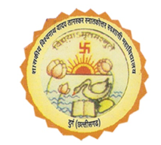
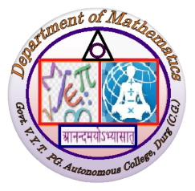
GOVT. V.Y.T. PG AUTONOMOUS COLLEGE DURG
Department of Mathematics
Teaching Plan
Academic Year – 2023-24

NAME : - AMBALIKA CHOUHAN CLASS :- M.Sc. I SEM
PAPER- II TITLE –REAL ANALYSIS– I
Month | Unit/Title | Topic of lectures | No. of lecture | Method/Mode of Delivery
August  September | I | Sequences and series of functions. Pointwise and uniform convergence. Cauchy criterion for uniform convergence. Weierstrass M-test, Abel’s and Dirichlet’s tests for uniform convergence. Uniform convergence and continuity. Uniform convergence and differentiation, Weierstrass approximation theorem. | 21 | 1.Chalk and talk method  2. Flip the class  3.Group discussion  4.Problem Solving
October | II | Power series uniqueness theorem for power series. Abel’s and Tauber’s theorems. Rearrangements of terms of a series. Riemann’s theorem. | 17
November | III | Functions of several variables linear transformations derivatives in an open subset of Rn, Chain rule, Partial derivatives, Interchange of the order of differentiation, Derivatives of higher orders, Taylor’s theorem, Inverse function theorem, Implicit function theorem. | 22
December | IV | Extremum problems with constraints. Lagrange’s multiplier method. Differentiation of integrals. Partitions of unity. Differential forms. Stoke’s theorem | 10

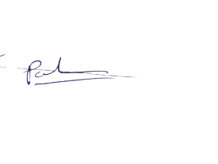
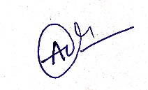
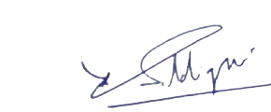

Teacher HOD Principal

GOVT. V.Y.T. PG AUTONOMOUS COLLEGE DURG
Department of Mathematics
Teaching Plan
Academic Year – 2023-24

NAME - AMBALIKA CHOUHAN CLASS - M.SC. II SEM
PAPER- II TITLE- REAL ANALYSIS (II)
Month | Covered Topic | Classes | Method/Mode of Delivery
January | Definition and existence of Riemann-Stieltjes Integral. Properties of the integral. Integration and differentiation. The fundamental theorem of calculus. Integration of Vector-valued functions. Rectifiable curves. | 18 | 1.Chalk and talk method  2. Flip the class  3.Group discussion  4.Problem Solving
February | Lebesgue outer measure. Measurable sets. Regularity. Measurable functions. Borel and Lebesgue measurability. Non-measurable sets. Integration of non-negative functions. The general integral. Integration of series. | 18
March | Measures and outer measures, Extension of a measure. Uniqueness of extension. Completion of a measure. Measure spaces. Integration with respect to a measure. Riemann and Lebesgue Integrals | 24
April | The four derivatives. Functions of bounded variation. Lebesgue differentiation theorem. Differentiation and integration. The L^{p}-spaces. Convex functions. Jensen’s inequality. Holder and Minkowski inequalities. Completeness of L^{p}. Convergence in measure. Almost uniform convergence. | 24
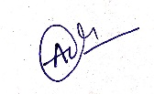
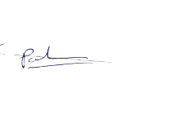

Teacher HOD Principal

GOVT. V.Y.T. PG AUTONOMOUS COLLEGE DURG
Department of Mathematics
Teaching Plan
Academic Year – 2023-24

NAME :- AMBALIKA CHOUHAN CLASS :B.SC. I SEM
PAPER- DSC TITLE- ELEMENTARY CALCULUS
Month | Unit/Title | Topic of lectures | No. of lecture | Method/Mode of Delivery
July/August | I | Contributions and Biography of Indian Mathematician: Bodhayan, Apasthamb, Katyayan, Mahaveeracharya, Brahmagupta and Bhaskarachaya in special context of Leelavati. Sequences, Continuity and Differentiability , Notation of convergence of sequences and series of real numbers, Definition of limit and continuity of a real valued function; Differentiability and its geometrical interpretation. Elementary Differentiation. | 22 | 1.Flip the class  2.Group discussion  3.Problem Solving  4.Virtual Classes
September | II | Expansion of Functions: Rolle’s Theorem, Lagrange’s mean value theorem, Cauchy’s mean value theorem and their geometrical interpretations, Successive differentiation and Leibnitz theorem, Maclaurin’s and Taylor’s theorems for expansion of a function. | 20
October/  November | III/IV | Curvature, Asymptotes,Curve Tracing: Curvature; Asymptotes of general algebraic curves, Parallel asymptotes, Asymptotes parallel to axes; Symmetry , Concavity and convexity, Points of inflection, Tangents at origin, Multiple points, Position and nature of double points; Tracing of Cartesian , polar and parametric curves. Integration: Elementary integration, Integration of Transcendental function, | 25
December | IV | Reduction formula, Definite Integral | 7

Teacher HOD Principal

GOVT. V.Y.T. PG AUTONOMOUS COLLEGE DURG
Department of Mathematics
Teaching Plan
Academic Year – 2023-24

NAME :-AMBALIKA CHOUHAN CLASS :B.SC. II SEM
PAPER- DSC TITLE- ALGEBRA
Month | Unit/Title | Topic of lectures | No. of lecture | Method/Mode of Delivery
January | I | Matrix Algebra: Introduction, elementary operations of matrices, Inverse of a matrix. Special types of matrices: Transpose of a matrices: Transpose of a matrix, Symmetric and Skew symmetric matrices, Hermitian and Skew Hermitian matrix, Rank of a matrix, Echelon form of a matrix , Normal form, Application of matrices to a systems of linear (both homogeneous and non-homogeneous ) equations, Theorems on consistency of a system of linear equations. Eigen values and Eigen values and Eigen vectors, Cayley Hamilton theorem,and its use in finding inverse of a matrix. | 15 | 1.Flip the class  2.Group discussion  3.Problem Solving  4.Virtual Classes
February | II | Sets Theory & Functions: Sets, subsets Set operations and the laws of set theory and Venn diagrams. Examples of finite and infinite set. Finite sets and counting principle. Empty set, properties of empty set. Standard set operations. Classes of a set. Power set of a set. Difference and symmetric difference of two sets. Set identities, Generalized union and intersection. Relations and Functions: Product set, Composition of relations, Types of relations, Partitions, Equivalence Relations with example of congruence modulo relation, Partial ordering relations. Function, Types of Function, Inverse Function, Composite of functions, Modular arithmetic and basic properties of congruences | 20
March | III | Theory of equations: Symmetric functions of the roots of an equation Root of a multiplicity, Synthetic division, Greatest common Divisors, Relation between the roots and coefficients of general polynomial equations in one variable. Transformation of equations . Decarte’s rule of signs. Solutions of cubic equations (Cardon method), Biquadrate equation. | 22
April | IV | Group Theory: Definition and properties of a group, Abelian groups, Examples of group, Subgroups and examples, Cosets and their properties, Lagrange’s theorem and its applications, Normal subgroups and their properties, Simple groups, Factors groups | 22

Teacher HOD Principal

GOVT. V.Y.T. PG AUTONOMOUS COLLEGE DURG
Department of Mathematics
Teaching Plan
Academic Year – 2023-24

Name :- AMBALIKA CHOUHAN Class :B.Sc. III SEM
Paper- DSC Title-ABSTRACT ALGEBRA
Month | Unit/Title | Topic of lectures | No. of lecture | Method/Mode of Delivery
August  September | I/II | Definition and examples of groups, Elementary Properties of groups, Symmetric group, Abelian Group, The Dihedral groups. Modulo, its properties and examples. Subgroups and examples of subgroups, Centralizer, Normalizer, Center of a group, Product of two subgroups. | 22 | 1.Flip the class  2.Group discussion  3.Problem Solving  4.Virtual Classes
October | III | Cyclic groups, Properties of Cyclic groups, Normal subgroups, Cosets, Properties of Cosets, Factor groups, Lagrange’s theorem. | 20
November | IV | Permutation groups, Cycle notation for permutations, Properties of Permutations, Even and odd Permutations, alternating groups. Group homomorphisms, Properties of homomorphisms | 23
December | V | Kernel of homomorphism, Group isomorphisms, Cayley’s theorem, Properties of isomorphisms, First, Second and Third isomorphism theorem for groups. | 23

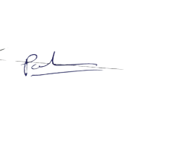

Teacher HOD Principal

GOVT. V.Y.T. PG AUTONOMOUS COLLEGE DURG
Department of Mathematics
Teaching Plan
Academic Year – 2023-24

Name :-AMBALIKA CHOUHAN Class :B.Sc. IV SEM
Paper- DSC Title- REAL ANALYSIS
Month | Unit/Title | Topic of lectures | No. of lecture | Method/Mode of Delivery
JANUARY | I | Algebraic and order properties of Absolute value of a real number; Bounded above and bounded below sets, Supremum and infimum of a nonempty subset of Real number. | 19 | 1.Flip the class  2.Group discussion  3.Problem Solving  4.Virtual Classes
FEBRUARY | II/III | The completeness property of R, Archimedean property, Density of rational numbers in Definition and types of intervals, Nested intervals property; Neighborhood of a point in , Open and closed sets in real number. Convergent sequence, Limit of a sequence, Bounded sequence. | 20
MARCH | III/IV | Limit theorems, Monotone sequences, Monotone convergence theorem, Subsequences, Bolzano-Weierstrass theorem for sequences, Limit superior and limit inferior for bounded sequence, Cauchy sequence, Cauchy’s convergence criterion. Convergence and divergence of infinite series of real numbers, Necessary condition for convergence, Cauchy criterion for convergence; Tests for convergence of positive term series: Integral test, | 25
APRIL | V | Basic comparison test, Limit comparison test, D’Alembert’s ratio test, Cauchy’s nth root test.  Alternating series, Leibniz test, Absolute and conditional convergence, Abel’s test, Dirichlet test, Test for absolute Convergence. | 25

Teacher HOD Principal

GOVT. V.Y.T. PG AUTONOMOUS COLLEGE DURG
Department of Mathematics
Teaching Plan
Academic Year – 2023-24

NAME:- AMBALIKA CHOUHAN CLASS - B.SC. III YEAR PAPER- II TITLE - ABSTRACT ALGEBRA

